Michigan CBA Maps
Flint MI
Detroit-Warren-Livonia, MI

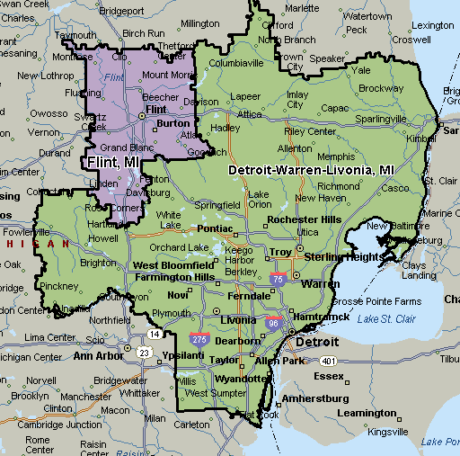

Grand Rapids-Wyoming, MI
