Mississippi CBA Maps
Jackson, MS
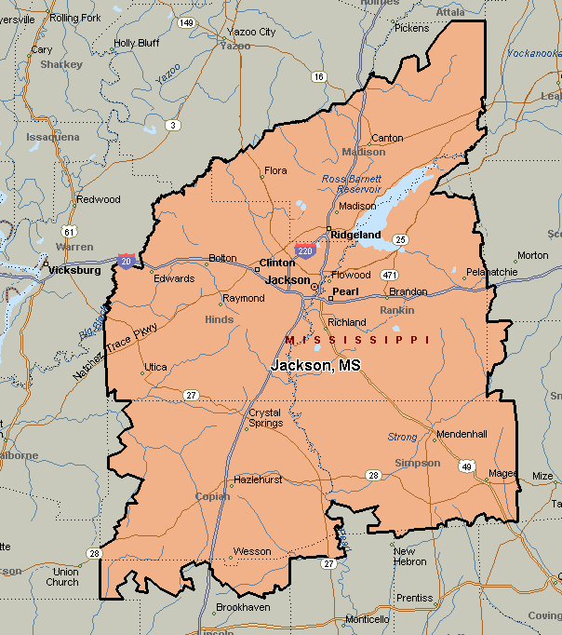

Memphis, TN-MS-AR
