Bridgeport-Stamford-Norwalk, CT
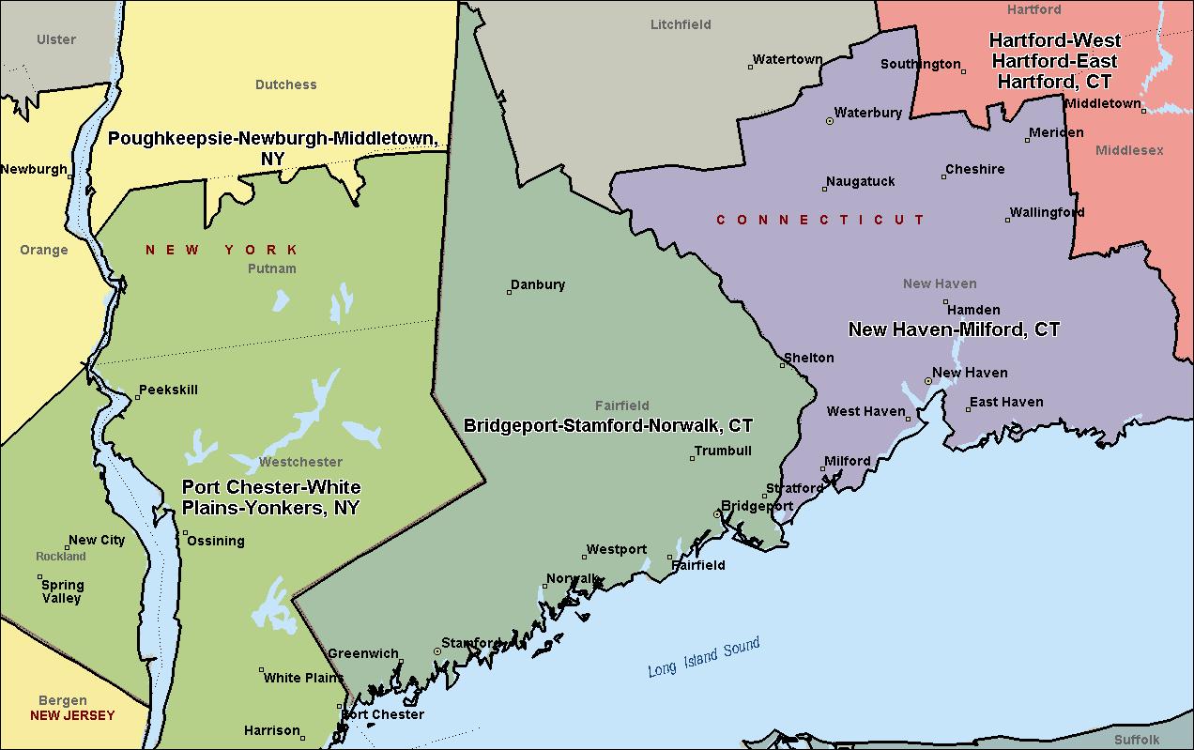

New Haven-Milford, CT
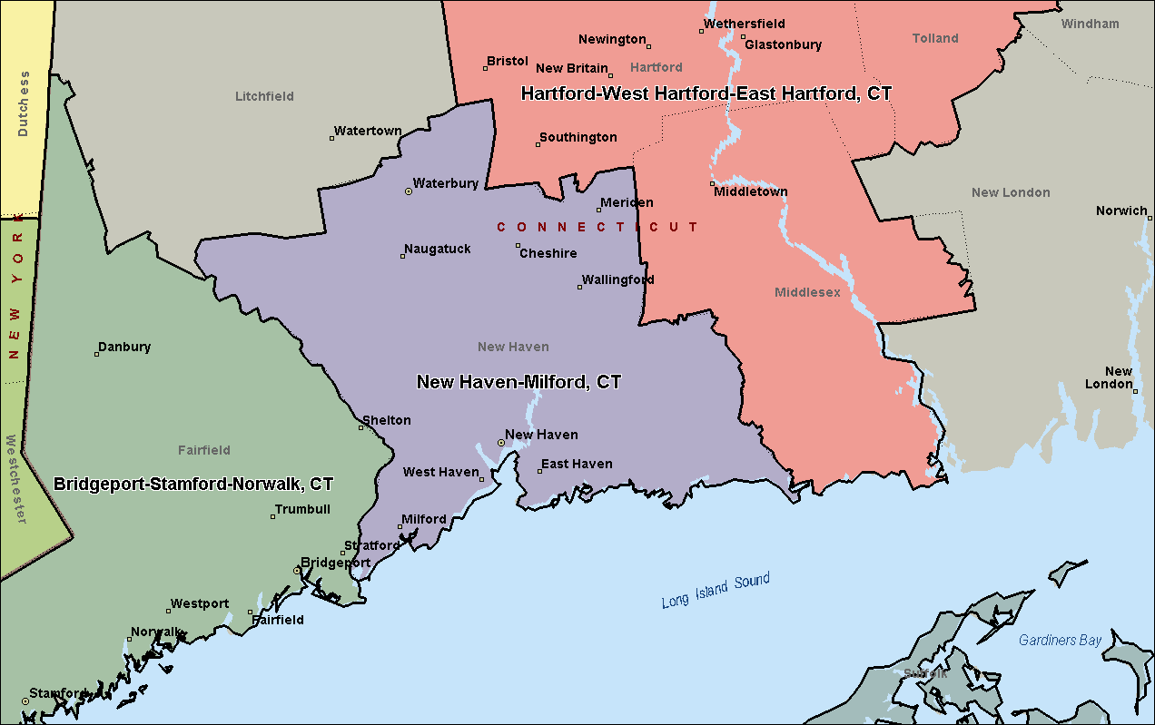

Hartford-West Hartford-East Hartford, CT
