Tennessee CBA Maps
Chattanooga, TN-GA
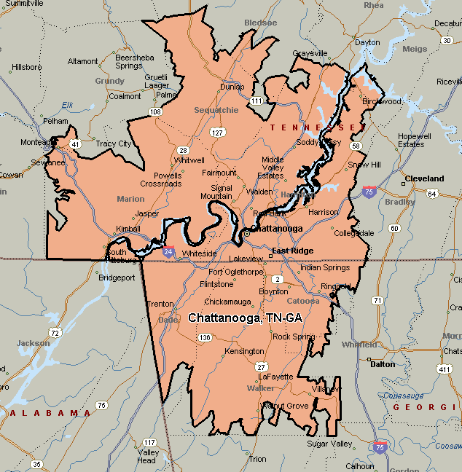

Knoxville, TN
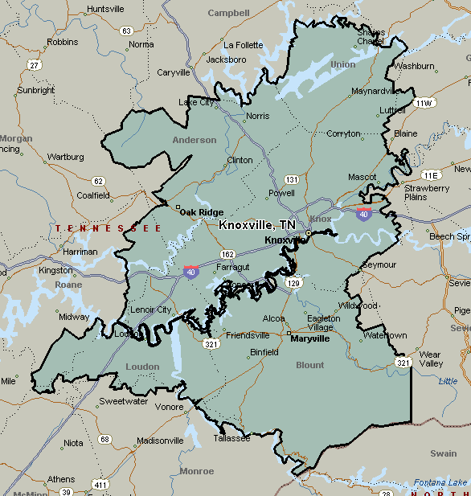

Nashville-Davidson-Murfreesboro-Franklin, TN
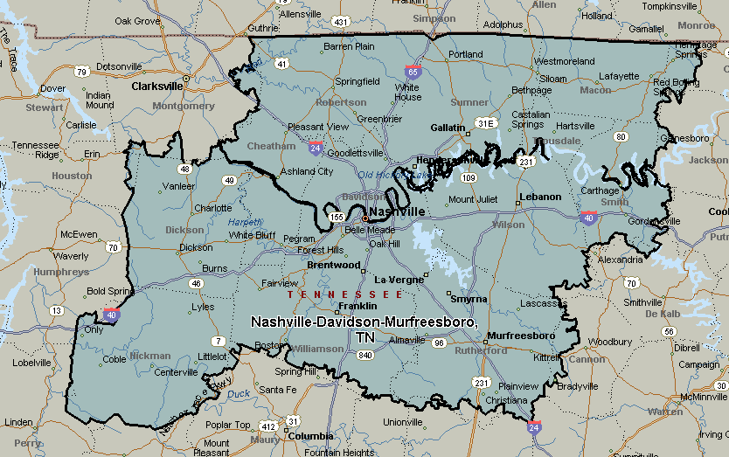

Memphis, TN-MS-AR
