**Texas CBA Maps**

**El Paso, TX**

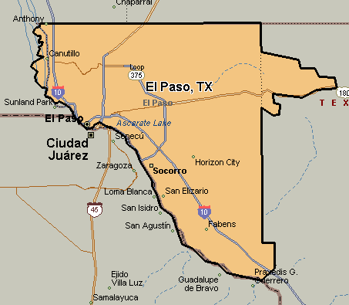

**Beaumont-Port Arthur, TX**

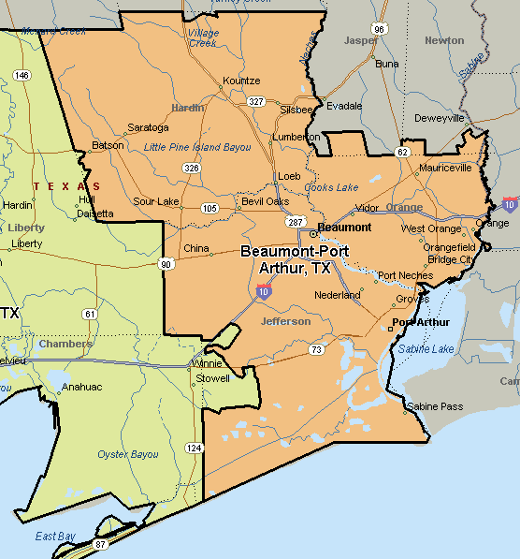

**Houston-Baytown-Sugar Land, TX**

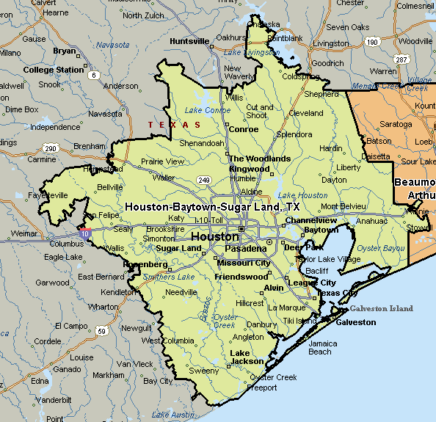

**Austin-Round Rock, TX**

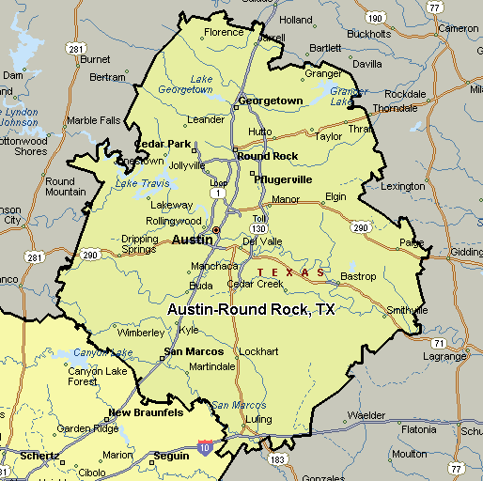

**San Antonio, TX**

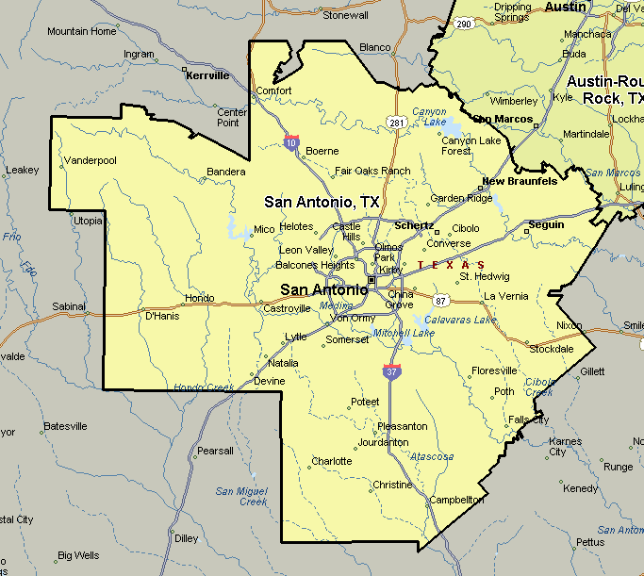

**McAllen-Edinburg-Pharr, TX**

