Virginia Beach-Norfolk-Newport News, VA
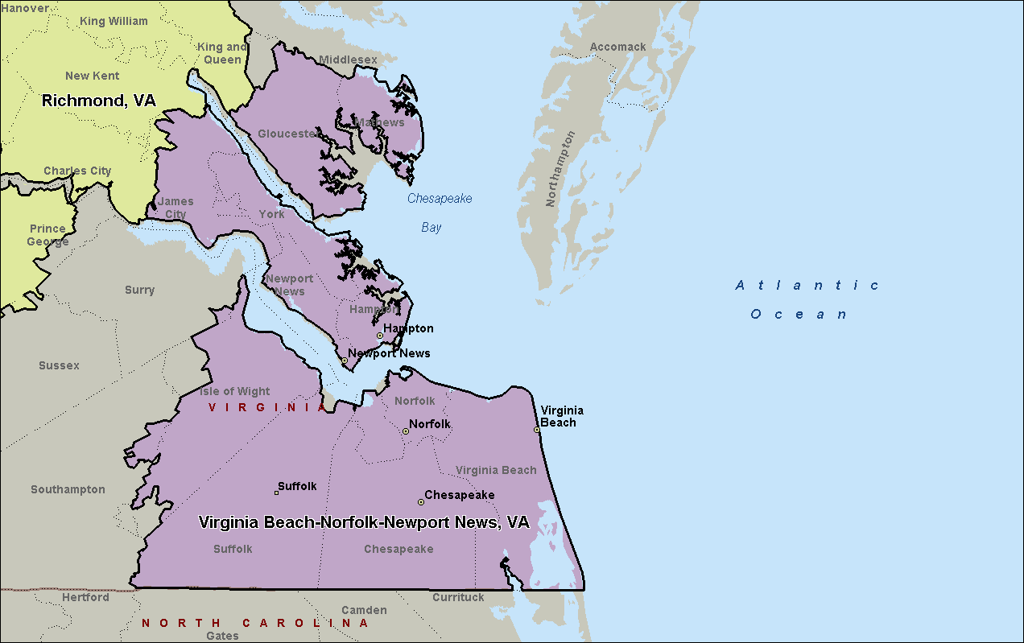

Richmond, VA
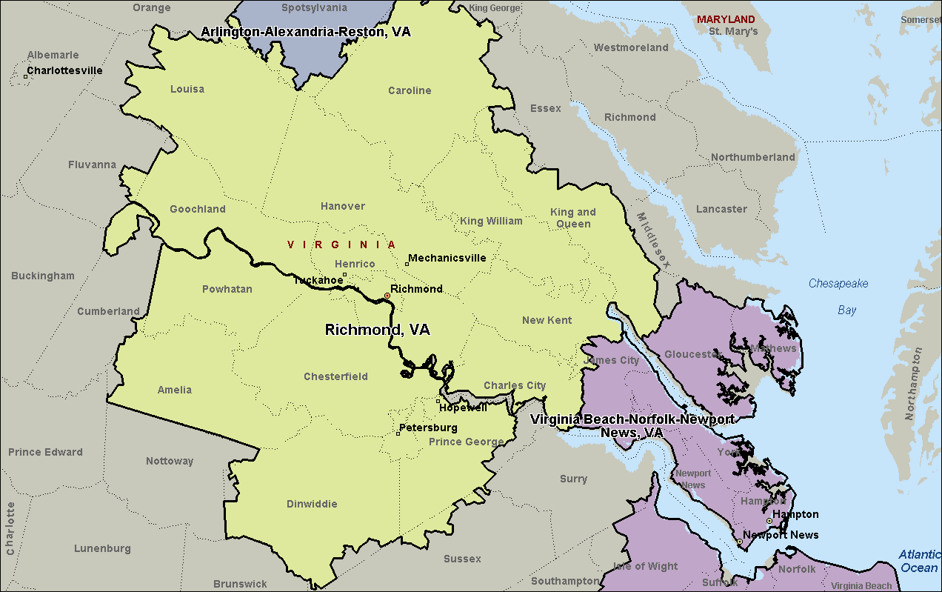

Arlington-Alexandria-Reston, VA
