**Arizona CBA Maps**

**Phoenix CBA**

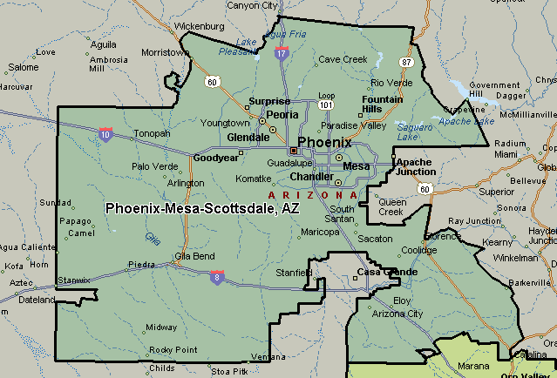

**Tucson CBA**

