**Ohio CBA Maps**

**Huntington-Ashland, WV-KY-OH**

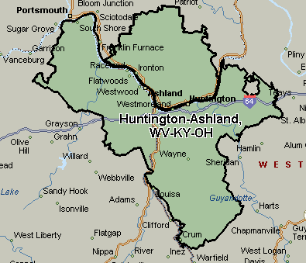

**Akron OH**

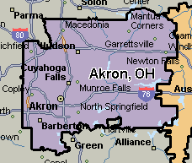

**Youngstown-Warren-Boardman, OH-PA**

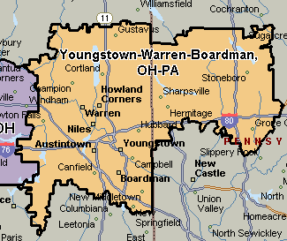

**Toledo, OH**

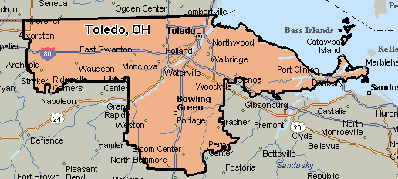

**Dayton, OH**

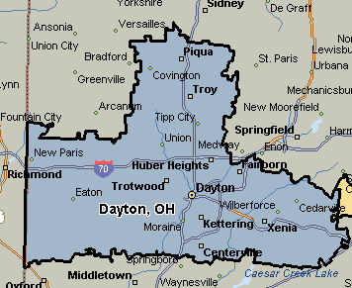

**Columbus, OH**

