**California CBA Maps**

**Sacramento-Arden-Arcade-Roseville, CA**

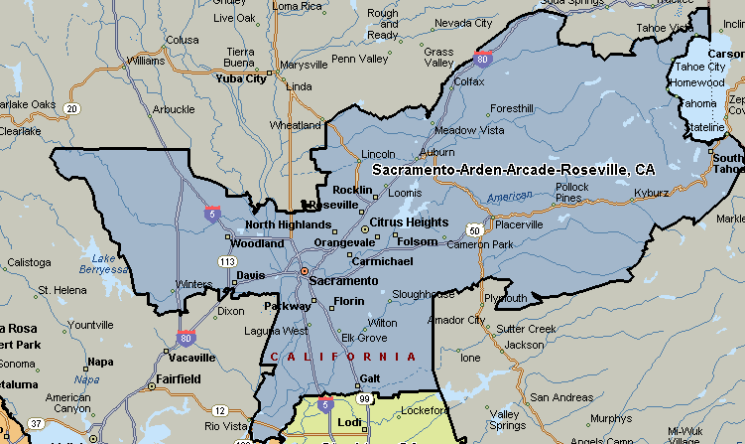

**Stockton, CA**

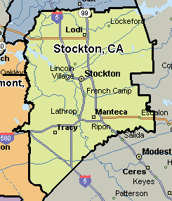

**San Francisco-Oakland-Fremont CA**

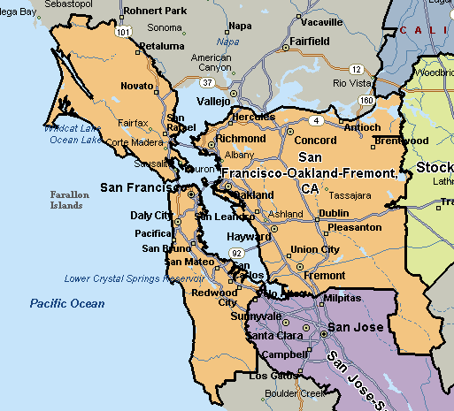

**Visalia-Porterville, CA**

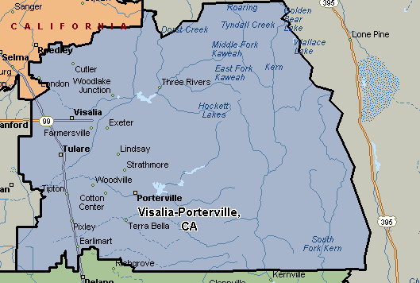

**San Jose-Sunnyvale-Santa Clara, CA**

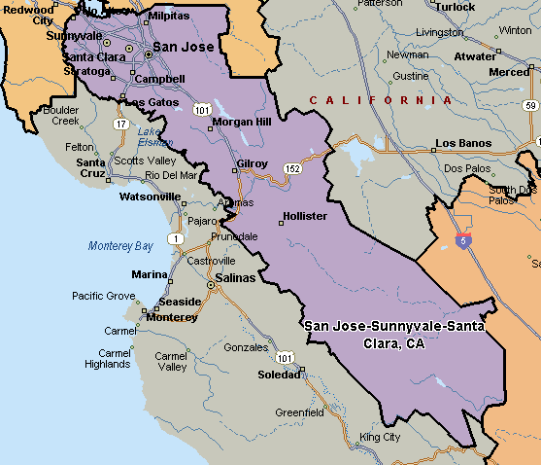

**Fresno, CA**

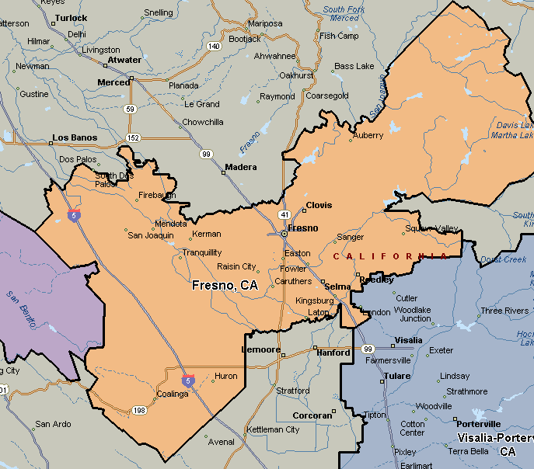

**Bakersfield, CA**

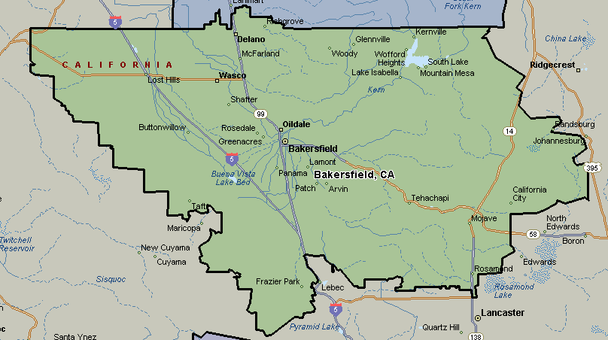

**Oxnard-Thousand Oaks-Ventura, CA**

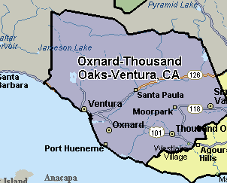

**Los Angeles County, CA**

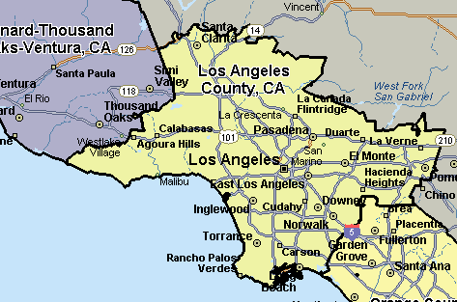

**Orange County, CA**

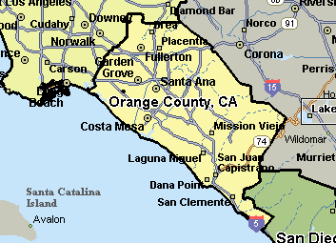

**San Diego-Carlsbad-San Marcos, CA**

