**Oklahoma CBAs**

**Oklahoma City**

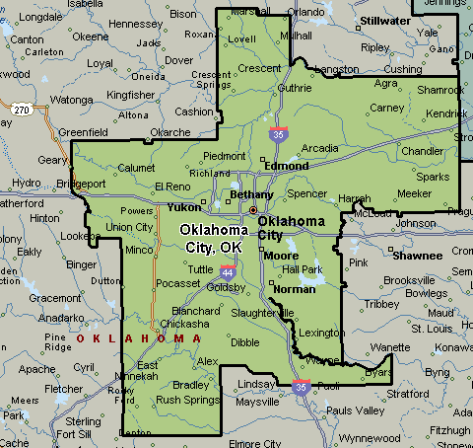

**Tulsa CBA**

