Camden, NJ

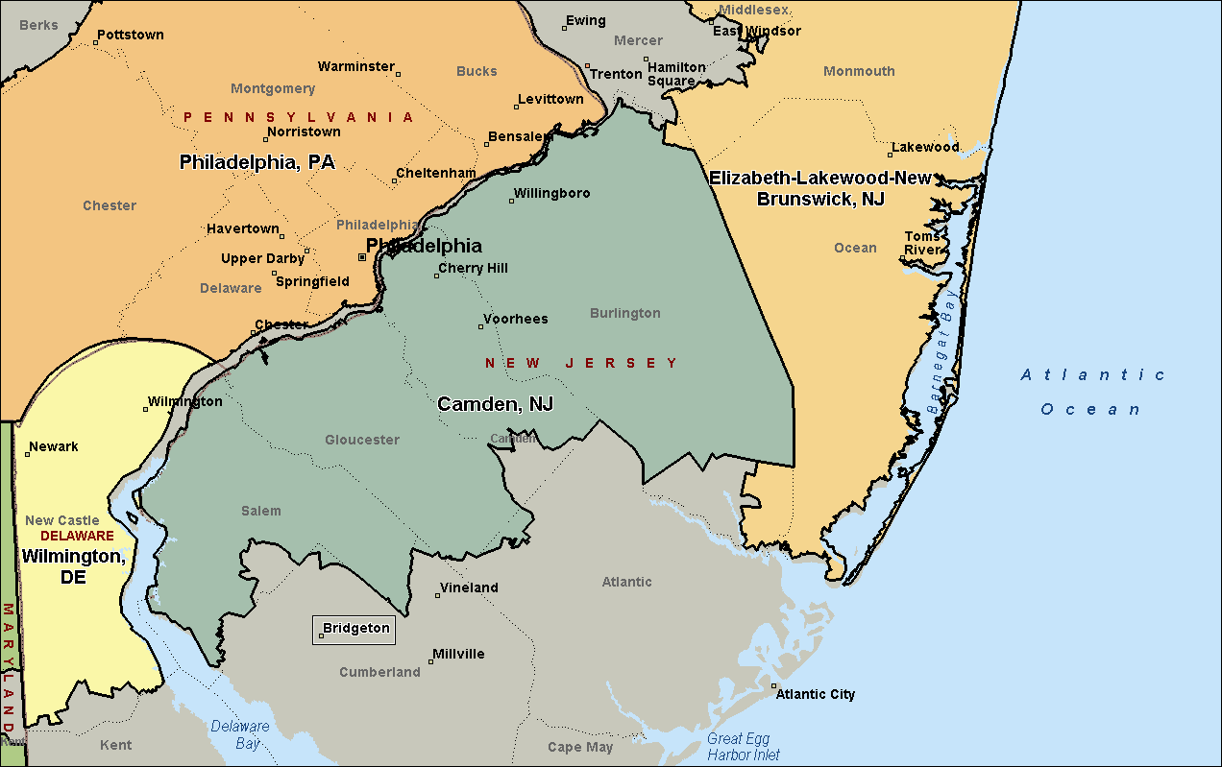

Elizabeth-Lakewood-New Brunswick, NJ

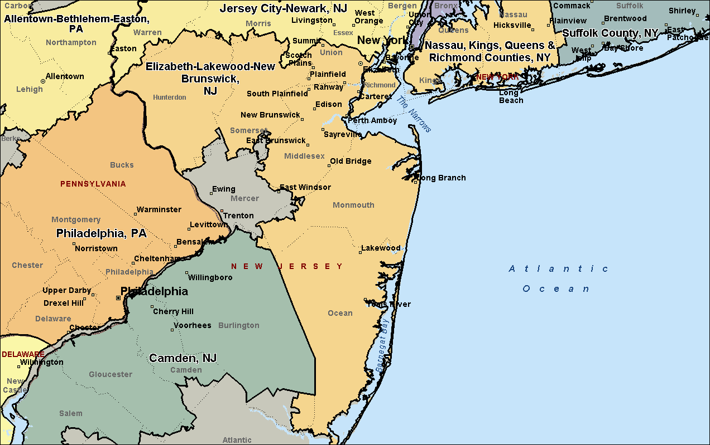

Jersey City-Newark, NJ

