Wisconsin CBA Maps
Minneapolis-St. Paul-Bloomington, MN-WI
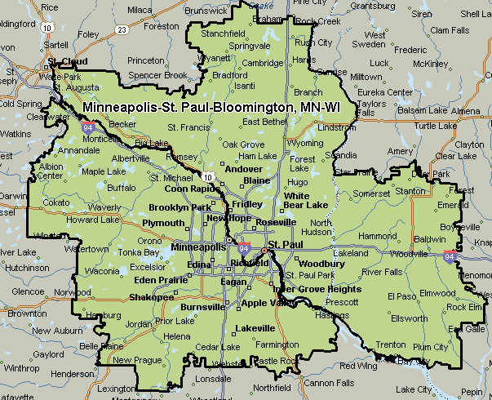

Milwaukee-Waukesha-West Allis, WI
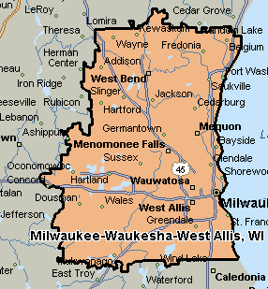
Northern-Chicago Metro, IL-WI
