Delaware CBA Map
Philadelphia-Camden-Wilmington, PA-NJ-DE-MD
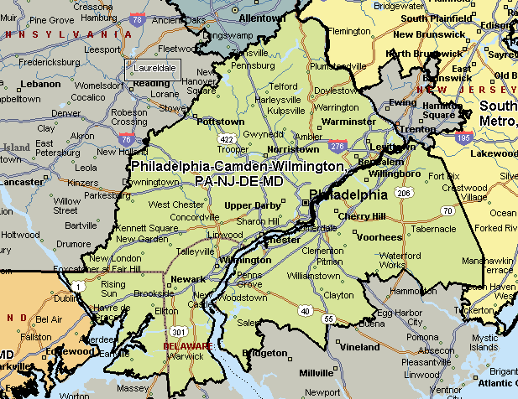D

