Baltimore-Columbia-Towson, MD
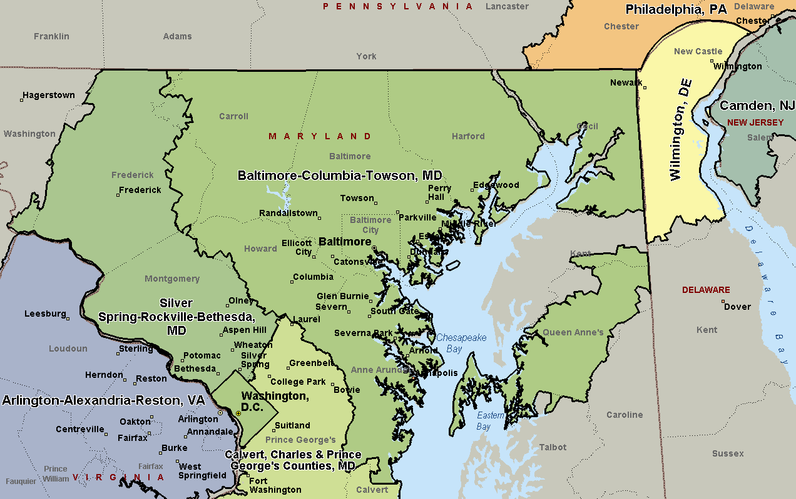

Silver Spring-Rockville-Bethesda, MD
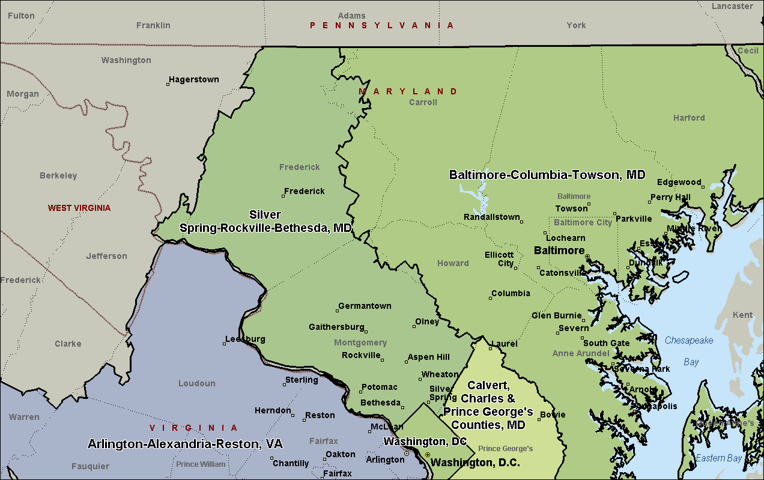

Calvert, Charles, & Prince George’s Counties, MD
