Maryland CBA Maps
Philadelphia-Camden-Wilmington, PA-NJ-DE-MD
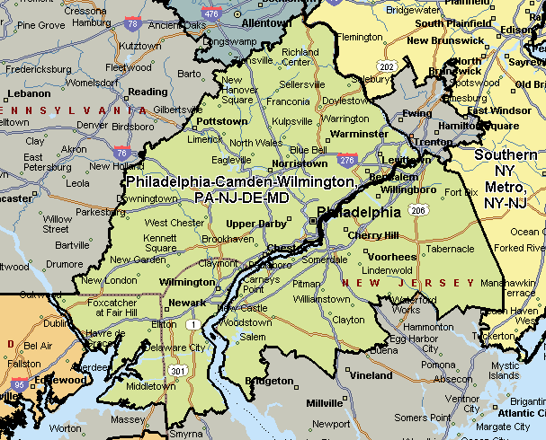

Washington-Arlington-Alexandria, DC-VA-MD-WV
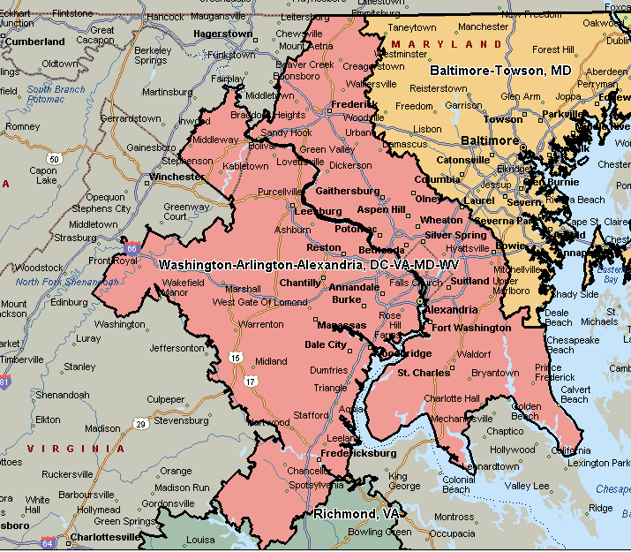

Baltimore-Towson, MD
